City of Morristown
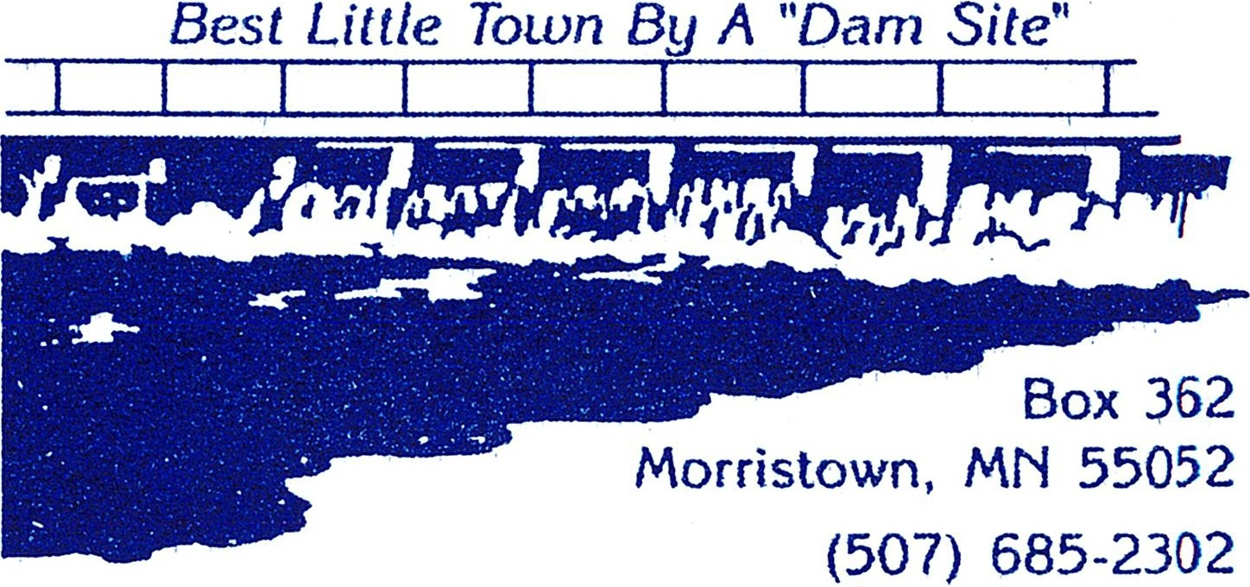
IN SOUTHERN MINNESOTA LAKES REGION

The City of Morristown is accepting applications
for a Zoning Administrator Position

The City of Morristown is seeking applicants for a zoning administrator position.
A completed application for Employment is required to be considered for this position.

Wages: Wage will be based on opening and closing permits, $22.50 per permit either opened or closed. In addition, $25 for attending the zoning meeting, the third Thursday of each month.
Working Hours: Varies, on call.
Application: Please pick up an “Application for Employment” at the City Clerk’s office, at 402 S Division Street, Morristown or find online at www.morristownmn.org
Deadline: Open until filled
For more information call 507-685-2302.
Email- mmueller@ci.morristown.mn.us
Mailing address is City of Morristown, 402 Division Street S., PO Box 362, Morristown, MN 55052
Sincerely,
Michael Mueller
City Administrator

